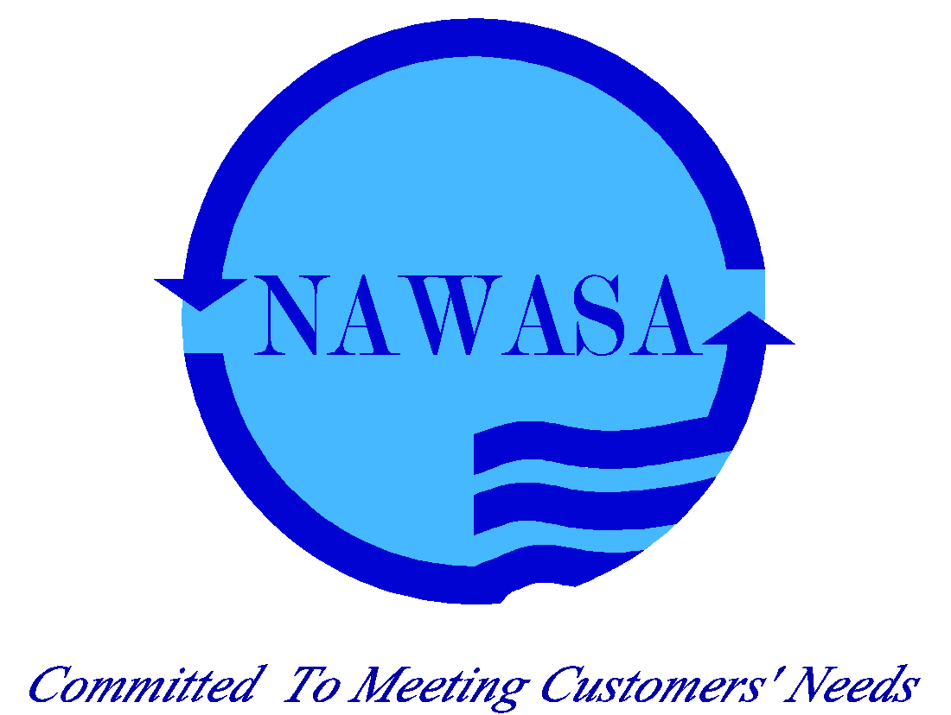

**NATIONAL WATER AND SEWERAGE AUTHORITY - NAWASA**

TERMS OF REFERENCE AND TECHNICAL SPECIFICATION FOR

**Ecological Assignment under the Water Transfer System**

FOR

G-CREWS PROJECT- COMPONENT 3

Issued for Tender only

**St. George’s, Grenada**

**May 21, 2025**

## List of Abbreviations

**BMU**: German Federal Ministry for the Environment, Nature Conservation and Nuclear Safety

**ESMP**: Environmental and Social Management Plan

**GCF**: Green Climate Fund

**G-CREWS**: Project Climate-Resilient Water Sector in Grenada

**GIZ**: German Development Corporation

**IFC**: International Finance Corporation

**IKI**: International Climate Initiative

**NAWASA**: National Water and Sewage Authority

## Project Context

The Government of Grenada, in partnership with the German Development Corporation (GIZ), is implementing the Project Climate-Resilient Water Sector in Grenada (G-CREWS). The project is jointly financed by the Green Climate Fund (GCF) and the German Federal Ministry for the Environment, Nature Conservation and Nuclear Safety (BMU) under its International Climate Initiative (IKI), and the Government of Grenada, with the main objective of increasing systemic climate change resilience in Grenada’s water sector.

Over a 6-year period, the Government of Grenada, the Grenada Development Bank and the National Water and Sewage Authority (NAWASA) in partnership with the German Development Corporation (GIZ) implements the project’s five components. The project’s holistic approach addresses two main climate risks and vulnerabilities of Grenada: freshwater availability and disaster preparedness. Other Caribbean communities share these vulnerabilities, rendering this project a model for regional application.

To achieve its objective, the project supports the water sector’s comprehensive transformation on multiple levels, which represents a nationwide ‘paradigm shift’ for Grenada’s overall resilience. This paradigm shift will include citizens and businesses as water users, the public sector as provider of potable water and infrastructure, and behavioral changes triggered through appropriate governance, regulation, economic incentives and raising awareness.

This translates into the following five outputs (components):

1. Climate-Resilient Water Governance
2. Climate-Resilient Water Users
3. Climate-Resilient Water Supply System
4. Additional Contributions of the Water Sector to Grenada’s NDC
5. Regional learning and replication

The contractor will contribute to the achievement of output 3, Climate-Resilient Water Supply Systems. One of the project’s identified measure is the increase of the water resources yield for the urban and semi-urban developments in the south-east of the island. The Government of Grenada plans to use G-CREWS funding to build a water transfer pipeline from the Great River to the Les Avocats and Petit Etang catchment area.

The existing Les Avocats Reservoir and the small existing dams in the Petit Etang catchment are important factors in the water supply system for the South-east of the island providing water to approximately 11.400 people. The safe yield of the existing reservoirs is currently not sufficient to fulfil this task.

To improve the safe yield of Les Avocats Reservoir a water transfer pipeline is planned to pump water in the dry seasons (16l/s during max. 90 days a year) from the Great River to the Upper Bacolet catchment.

Water is collected in a lateral water intake below the Seven Sisters waterfalls in the Great River. Right after the intake there will be a booster pump station which will pump the water following the main road up to the antenna point at 1910. From there, the water is gravity fed to the Les Avocat Reservoir.

The entire roadside from the Grand Etang Main Road up to 1910 where the utility antennas are erected is part of the project site. The site extends southward through the Grand Etang Forest Reserve, crossing several steep slopes unto the Les Avocats Reservoir. The ecological study area for the proposed project comprises the Great River around the point of abstraction to include the adjacent riparian, the location of the pump station, the roadway along the proposed pipe route to be installed, and parts of the Grand Etang Forest Reserve where the transmission pipes are to be placed. The Grand Etang Lake and adjacent wetland ecosystem and the Adelphi/Gangadee Waterfall are excluded from the ecological study area since they are not influenced and/or affected by the intervention.

## Environmental Context

The Government of Grenada envisions that the use of natural resources fulfils the basic needs of the people and development of the nation in equilibrium with economic growth, technology development, environmental protection and social equity.

NAWASA will be responsible for ensuring that all activities of the Project are implemented in a manner consistent with international environmental standards and applicable Grenadian environmental laws and regulations. NAWASA will also have responsibility for overseeing the implementation of the Environmental and Social Management Plan (ESMP) for all activities in the Project and verifying that the contractors will implement relevant mitigation measures as defined in and required by the ESMP.

The ESMP of the 7 Sister water transfer project was developed and published and outlines the requirements for implementation. Performance Standard 6, recognizes that protecting and conserving biodiversity, maintaining ecosystem services and sustainable management living natural resources are fundamental to sustainable development (IFC, 2012). Measures presented should comply with the Convention on Biological Diversity and Grenada’s National Biodiversity Strategy and Action Plan, the Revised Forest Policy, and related policy and legal instruments.

One of the interventions makes provisions for the development and implementation of a Terrestrial Biodiversity Management Plan designed to protect and conserve forest vegetation, habitats, and wildlife.

**This consultancy seeks to engage the services of an ecologist to monitor the forest for critical life cycle activities of terrestrial animals and thereby to limiting direct impact to wildlife in vulnerable life cycle periods during the construction of the 7-sister water transfer pipeline.**

## Scope of Work

The consultant will be responsible for the following tasks:

**Development and Monitoring of Terrestrial Biodiversity Management Plan for the 7 Sister Water Transfer Project Construction Period:**

* 1. **Development of Terrestrial Biodiversity Management Plan (TBMP):**
  + Review the ESIA & ESMP of the 7 Sister Water transfer project and complement, if necessary, the assessment of the ecological study area to identify critical life cycle activities of terrestrial animals.
  + Develop a TBMP that includes strategies to monitor and mitigate impacts on wildlife during the construction period.
  + Ensure the TBMP complies with Performance Standard 6, the Convention on Biological Diversity, Grenada’s National Biodiversity Strategy and Action Plan, and the Revised Forest Policy.
  + Monitor the forest for critical life cycle activities of terrestrial animals to limit direct impact to wildlife in vulnerable life cycle periods.
  + Preserve vegetated buffers and corridors to limit the negative impacts of noise, edge effect, and light on biodiversity.
    1. **Habitat Restoration:**
  + During the planning and construction period, recommend habitat restoration through the replanting of vegetation in affected areas along the pipe-laying route, especially on slopes where vegetation is damaged or destroyed to allow for the installation of pipes.
  + Ensure restoration is done with native vegetation, including endemics, consistent with the existing ecosystem.
    1. **Vegetation Removal Plan:**
  + **In consultation with the Forestry Department and NAWASA, develop a** vegetation removal plan before the commencement of land preparation to avoid the unnecessary removal of trees.
  + Ensure that any vegetation removal is minimized and that mitigation measures are in place to restore affected areas.
    1. **Work Plan Development:**
  + Develop a detailed work plan outlining the activities, timelines, and responsible parties for the implementation of the TBMP.
  + Ensure the work plan is aligned with the ESMP and the overall project timeline and milestones of the 7 sisters water transfer project.
  1. **Monitoring and Reporting of TBMP**
  + Monitor the implementation of the TBMP through regular (min. bi-weekly) field visits.
  + Prepare monthly progress reports and final report.

## Profile of Expert

**Qualifications**

1. **Education/Training:**
   * A degree in Ecology, Environmental Science, or a related field.
   * Additional training or certification in biodiversity management and environmental impact assessment.
2. **General Professional Experience:**
   * At least 8 years of experience in ecological monitoring and biodiversity management.
   * Proven experience in developing and implementing environmental management plans.
3. **Specific Professional Experience:**
   * Experience in conducting ecological assessments and developing biodiversity management plans for infrastructure projects.
   * Knowledge of Grenada’s biodiversity and environmental regulations.
4. **Regional Experience:**
   * Experience working in the Caribbean region, with a focus on Grenada.
   * Familiarity with the ecological and environmental context of Grenada.
5. **Language:**
   * Proficiency in English, both written and spoken.

## Specification of inputs

|  |  |  |  |  |
| --- | --- | --- | --- | --- |
| **Fee days** | **Number of experts** | **Number of days per expert** | **Total** | **Comments** |
| **Expert** | 1 | 10 | 10 | Includes all tasks related to the development of the TBMP(Task 4.1 above). |
| **Expert** | 1 | 15 | 15 | Includes all task related to the monitoring and reporting of the TBMP (Task 4.2 above). Assuming 5 months of construction activities (3 days per months input time). |
| **Travel expenses** | **Quantity** | **Price (EUR)** | **Total (EUR)** | **Comments** |
| **Per-diem allowance in country of assignment** |  |  |  |  |
| **Other costs** | **Number** | **Price (EUR)** | **Total (EUR)** | **Comments** |
| **Flexible remuneration** |  |  |  |  |

## Input from NAWASA or Other Actors

The consultant will work closely with NAWASA, the Forestry Department at the Ministry of Ministry of Economic Development, Planning, Tourism, Creative Economy, Culture, Agriculture and Lands, Forestry, Marine Resources and Cooperatives, the GIZ and other relevant stakeholders to ensure the successful implementation of the TBMP. Key inputs from NAWASA and other actors may include:

* **Technical Support:** Provision of technical support and expertise related to the water transfer project and environmental management.
* **Data and Information:** Access to relevant data, reports, and information related to the ecological study area and the water transfer project.
* **Coordination:** Facilitation of coordination meetings and workshops to ensure effective communication and collaboration among stakeholders.
* **Monitoring and Evaluation:** Support in monitoring and evaluating the implementation of the TBMP and providing feedback for continuous improvement.

## Requirements on the Format of the Tender

The tender submission should include the following:

1. **Technical Proposal:**
   * Detailed methodology for developing and implementing the TBMP.
   * Work plan outlining the activities, timelines, and responsible parties.
   * Qualifications and experience of the consultant and any supporting team members.
   * Curriculum Vitae (CV) of the consultant and any supporting team members.
   * Any additional supporting documents or references
   * References from previous similar projects.
2. **Financial Proposal:**
   * Detailed breakdown of costs, including fee days and other costs.
   * Total cost of the consultancy services.
3. **Compliance Statement:**
   * Statement confirming compliance with all relevant environmental standards, regulations, and requirements.
   * Commitment to implementing the ESMP and relevant mitigation measures.

## Annexes

Detailed Environmental and Social Impact Assessment (ESIA) and Environmental and Social Management Plan (ESMP) report for the 7 Sister water transfer project. [giz2024-en-G-CREWS-7sister-ESIA-ESMP-report.pdf](https://www.giz.de/en/downloads/giz2024-en-G-CREWS-7sister-ESIA-ESMP-report.pdf)

## Timeline

The consultancy is expected to be completed within a period of 6 months from the date of contract signing. The timeline may include the following key milestones:

1. **Kick-off Meeting:** Within 1 week of contract signing.
2. **Development of TBMP:** Within 1 months of the kick-off meeting.
3. **Implementation of TBMP:** Over the remaining 5 months, with regular progress reports to NAWASA and other stakeholders.
4. **Final Report and Presentation:** Within 1 week of the completion of the implementation phase.

## Reporting

The consultant will provide regular progress reports to NAWASA and other relevant stakeholders. The reports should include:

* **Monthly Progress Reports:** Detailed updates on the activities, achievements, and any challenges encountered.
* **Final Report:** Comprehensive report summarizing the entire consultancy process, including the development and implementation of the TBMP, findings, recommendations, and lessons learned.